
a
Company
Logotype

Cone Beam Computed Tomography- Report



Porur Dental X-rays & CBCT

Patient Name : Mr. Chandrasekar | Date of Report : 17.06.2024
Age/ Gender : 38 years/ Male | Region of Interest : CBCT Maxilla
Referring doctor: Dr. S. Subramoniam | Indication : Nil
Clinical Notes: Nil
PATIENT INFORMATION

CBCT- Maxilla provided
CBCT – IMAGE DETAILS

RADIOGRAPHIC INTERPRETATION

- Completely missing crown and root portion in relation to 11.
- The maxillary alveolar ridge is present with normal trabecular pattern.
- Fractured crown: 21 (Involving enamel and dentin).
- The labial cortical bone in relation to 11 region appears to be discontinuous.

IMPLANT ASSESSMENT

 | 11 region
Sub-Crestal | 8.18
Mid- Crestal | 9.17
Distance between the alveolar ridge and Floor of the Nasal cavity (in mm) | 9.26

RADIOGRAPHIC IMPRESSION

- Partially edentulous maxillary arch- 11 region.
- Fractured tooth crown: 21.

Kindly correlate with clinical findings


IMAGES FOR REFERENCE

RECONSTRUCTED PANORAMIC VIEW
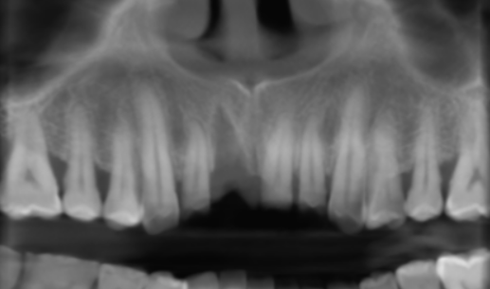

3-DIMENSIONAL VIEW

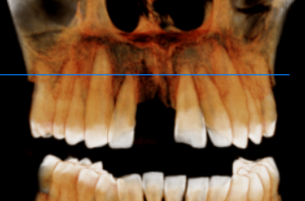

CROSS SECTIONAL VIEW

11 region | 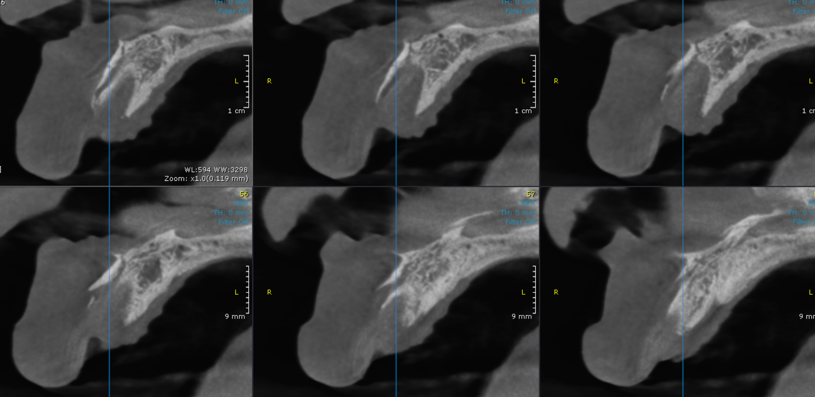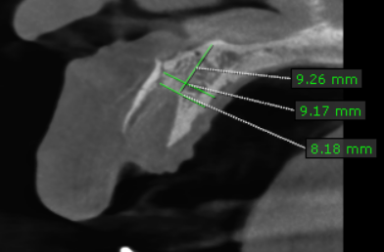

**** End of report ****

